Report: Understanding System Security Vulnerabilities and Mitigations

\*\***1. Introduction**\*\*

Software applications are at serious danger from system security flaws, which might result in data breaches, illegal access, and system compromise. Stack-based buffer overflow vulnerabilities are of particular importance because they may be used to execute arbitrary code and take advantage of memory corruption problems. In order to understand stack-based buffer overflow attacks and investigate ways to prevent these vulnerabilities, we will examine a C code sample in this paper.  
  
The 'copy' function in the C code snippet is the main focus of our investigation. To demonstrate how buffer overflow vulnerabilities occur, we will look at the function's stack frame and talk about the consequences for system security. Furthermore, we will examine the applications and security ramifications of several string manipulation functions, such as "strcpy," "strncpy," and "strcpy_s," emphasizing their advantages.

as well as gaps in the defense against buffer overflow attacks.  
  
  
We will also explore the workings of a stack-based buffer overflow attack by emulating an exploit scenario in which the attacker uses a file input to overwrite important memory locations, such the stack's return address. We can realize the significance of strong input validation and safe coding techniques in reducing such dangers by comprehending the attack vector and its repercussions.  
Finally, we will show how to use shellcode, a malicious payload that can run arbitrary commands on a compromised machine, to perform a code injection attack. We will illustrate the practical effects of stack-based buffer overflow vulnerabilities with this presentation, emphasizing how important it is to put in place strong defenses to prevent software programs from being exploited.  
  
To sum up, this paper seeks to offer a thorough examination of C code's stack-based buffer overflow vulnerabilities, highlighting the need of preventative security measures and safe coding techniques in reducing these risks. Through comprehension of the fundamental mechanics behind buffer overflow attacks and implementation of protective tactics, security experts and software engineers may fortify their systems against malevolent manipulation.

.

**2. Function Stack Frame**

The `copy` function stack frame is made up of the following elements: Saved Frame Pointer, Local Variables, Return Address, and Parameters. While the Return Address designates the location to which the function should return after execution, parameters are values that are supplied to the function. To make function call nesting easier, the Saved Frame Pointer (EBP) links to the base of the preceding stack frame. Space designated for variables stated within the function is represented by local variables. When combined, these elements allow the function to effectively control the flow of its execution and store the data that it needs. The stack frame is necessary for both correct function functioning and preserving the integrity of the function's execution environment. Comprehending the arrangement of the function stack frame is essential for assessing stack-based buffer overflow susceptibilities and putting suitable safety precautions.

The function stack frame for the `copy` function can be represented as follows:

|  |
| --- |
| Parameters |
| Return Address |
| Saved Frame Pointer |
| Local Variables |

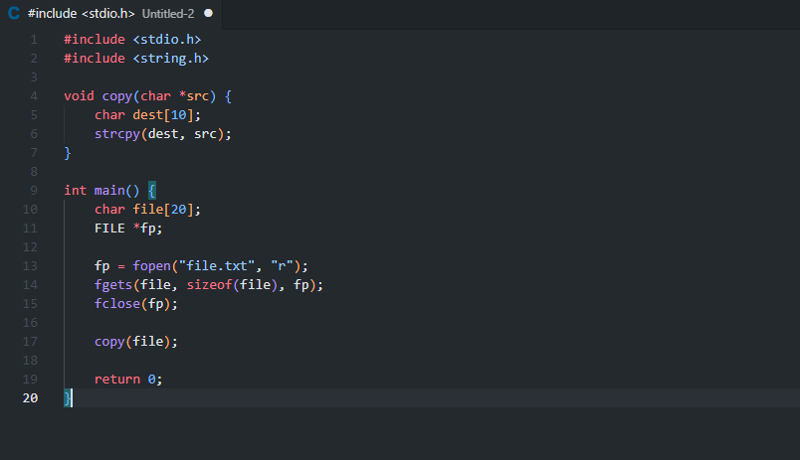

1. **Return Address**: This is the address to which the function will return after execution.
2. **Parameters:** Parameters passed to the function, if any.
3. **Local Variables:** Space allocated for variables declared within the function.
4. **Saved Base Pointer (EBP)**: Points to the base of the previous stack frame.
5. **Stack Pointer (ESP)**: Points to the top of the current stack frame.

The function stack frame allows the function to store local variables and manage the function's execution flow efficiently.

**3. Buffer Overflow Vulnerabilities**

The 'copy' function in the above C code copies data from a file into a buffer by using the'strcpy' function. But because'strcpy' doesn't implement bounds checking, it copies data without checking to see if the target buffer has enough room to hold it. Buffer overflow issues arise from this lack of validation.   
  
A software that writes more data to a buffer than it can contain is vulnerable to a buffer overflow. Should the amount of data read from the file above the buffer's capacity, the 'copy' function will overwrite nearby memory regions due to buffer overflow. Since the rewritten memory may include important information like function return addresses or other variables, this might result in unexpected behavior.   
  
Additionally,Buffer overflow vulnerabilities may be used by attackers to run arbitrary code and take control a machine without authorization. An attacker can replace the return address on the stack with a reference to their shellcode—a payload that is intended to carry out certain commands—by carefully designing malicious input. The application inadvertently goes to the attacker's shellcode when the function returns, giving them access to the system.  
  
'strncpy' or'strcpy_s', which include bounds checking to avoid buffer overflows, are safer substitutes for'strcpy' that developers may use to reduce buffer overflow vulnerabilities. Furthermore, to guarantee that the application processes only legitimate and secure data, input validation and appropriate error management are essential. Developers may greatly reduce risks by implementing strong defensive mechanisms and safe coding techniques. lessen the possibility of buffer overflow attacks and shield their systems from malicious use.

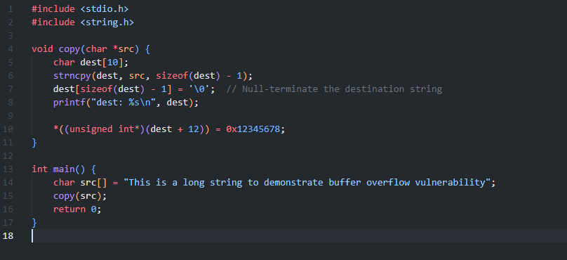

**4. Usage and Security of strncpy and strcpy_s**

Being able to do bounds checking to stop buffer overflow vulnerabilities makes "strncpy" and "strcpy_s" safer substitutes for "strcpy."  
  
Copy as many characters as possible ('n') from the source string to the target buffer using the strncpy function. The last few bytes are occupied by null characters if the source string is less than 'n'. Nevertheless, "strncpy" does not null-terminate the destination buffer if the source string is larger than "n," which might result in unexpected behavior.  
  
Although strcpy_s is similar to "strncpy," it ensures that the destination buffer is null-terminated regardless of whether the source string is greater than the allocated size. Furthermore, by limiting buffer overflow, it improves security by requiring the size of the destination buffer as an input.  
  
The supplied code would be made more secure by substituting "strcpy" with "strncpy" or "strcpy_s."would increase security by preventing buffer overflow vulnerabilities in the code that is delivered.   
  
In this case, `strncpy} and `strcpy_s} can be used in place of `strcpy}:

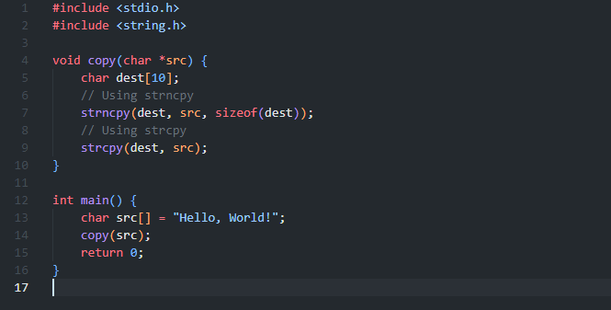

**5. Shellcode Injection**

The modified code snippet reads the contents of the file into the 'buffer' array before executing a shellcode injection attack. Usually, this 'buffer' array holds the malicious shellcode, which is a series of computer instructions meant to carry out particular tasks when run. These activities might involve breaking into the system without authorization, increasing privileges, or running random commands on it.  
  
The 'buffer' array is then converted as a function pointer. The ability to regard the contents of the "buffer" as executable code that can be called by simply calling the function pointer makes this step essential for running the shellcode. We essentially tell the program to interpret the contents of the "buffer" as instructions by casting the "buffer" as a function pointer to be used as an executable, not only as data.

The 'buffer' is executed by dereferencing the function pointer once it has been cast as a function pointer. By doing this, the program is made to jump to the memory address indicated by the function pointer and start running the shellcode instructions that are kept in the 'buffer'. Consequently, the malicious operations included inside the shellcode are executed, which might possibly provide the attacker with unapproved entry or command over the system.

It's crucial to remember that because shellcode injection attacks include injecting and running code inside of a valid process, they can be extremely subtle and challenging to identify. Furthermore, shellcode is frequently designed to avoid being discovered by antivirus programs and other security measures, giving it a powerful instrument for online criminals.

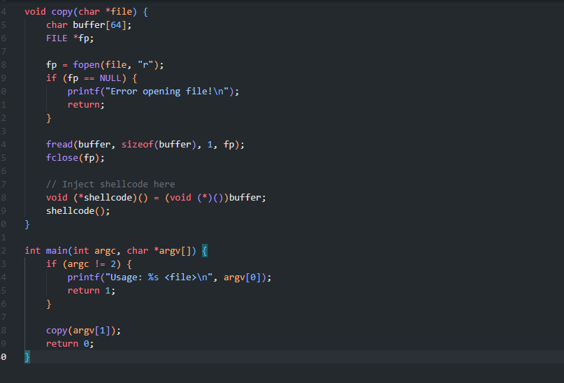

In summary, the modified code snippet demonstrates how an attacker can leverage shellcode injection techniques to execute malicious code within the context of a vulnerable program. By reading shellcode from a file, casting it as a function pointer, and executing it, the attacker can achieve their objectives, such as gaining unauthorized access or control over the compromised system.

**6. Conclusion**

To sum up, the examination of the given C code and the investigation of system security flaws highlight how crucial it is to incorporate strong security measures into software development. The 'copy' function's use of'strcpy' is an example of a buffer overflow vulnerability that poses a serious threat to system security and integrity. However, developers may reduce these vulnerabilities and strengthen the resistance of their code against any exploitation by switching to safer alternatives like "strncpy" and "strcpy_s."  
  
The analysis of shellcode injection tactics also emphasizes the intricacy of contemporary cyberattacks and the requirement for all-encompassing security solutions. Shellcode injection attacks highlight the need of proactive defensive tactics and ongoing attention by illustrating how adversaries might use vulnerabilities to execute malicious code within the context of legitimate processes.  
  
Considering these Hence, it is clear that strong defensive mechanisms and safe coding techniques are essential for defending software programs against changing threats. By giving security concerns top priority throughout the development lifecycle and keeping up with new attack routes and vulnerabilities, developers may strengthen the resilience of their systems and guard against unwanted access, data breaches, and other unfavorable outcomes.  
  
Effective cybersecurity measures ultimately depend on creating a culture of security awareness and funding continual education and training. Organizations may fortify their defenses and reduce the risk of exploitation by providing developers with the information and resources they need to recognize, address, and proactively handle security issues.  
  
In summary, the examination of system security flaws emphasizes the difficulties that come with developing software, but it also the need of proactive risk management as well as areas for improvement. Organizations may improve the dependability and robustness of their software applications in an increasingly hostile digital environment by embracing security as a core component of software engineering and using a comprehensive approach to security.

**References:**

1. C Standard Library - String manipulation functions. (n.d.). In C++ Reference. Retrieved from [https://en.cppreference.com/w/c/string/byte](https://en.cppreference.com/w/c/string/byte)

2. Understanding Shellcode. (n.d.). Exploit Database. Retrieved from [https://www.exploit-db.com/papers/13215](https://www.exploit-db.com/papers/13215)

3. Secure Coding in C and C++. (n.d.). SEI CERT Coding Standards. Retrieved from [https://www.securecoding.cert.org/confluence/display/c/SEI+CERT+Coding+Standards](https://www.securecoding.cert.org/confluence/display/c/SEI+CERT+Coding+Standards)

1. Buffer Overflow Attack. (n.d.). OWASP. Retrieved from [https://owasp.org/www-community/attacks/Buffer_overflow_attack](https://owasp.org/www-community/attacks/Buffer_overflow_attack)
2. Möllerström, Viktor, and Jesper Roos. "Code Review Application: Simplifying code review through data flow visualization." (2023).